“DESIGN OF HIGH VOLTAGE GAIN, VARIABLE OUTPUT DC-DC CONVERTER FOR HI-REL APPLICATIONS”

*Mid Semester Review*

*Submitted in partial fulfillment of the requirement of*

B.Tech in ELECTRONICS AND COMMUNICATION ENGINEERING

*By*

RISHIT THAKKAR (19EC413)

*Under the guidance of*

*Mr. NANDHA KUMAR (SAC, ISRO)*

*DR. DARSHANKUMAR DALWADI (BVM)*

**

\

Birla Vishvakarma Mahavidyalaya (Engineering College)

February – 2023

Contents

Abstract 3

Introduction 4

Problem Statement 5

Literature Review 5

Scope/ Application 14

Block Diagram of the System 15

Flow Chart of the system 16

Work Done 17

References 23

# Abstract

Multiple systems on-board a satellite require a translator or rotational motion. This has traditionally been accomplished by mechanical motors and related mechanical systems. However, these mechanisms are bulky. In view of reducing the overall mass of such systems, satellites are largely shifting to a piezo-actuated approach. Examples of these systems are optical Fast steering mirrors. These actuators are typically requiring large controllable bias voltages (150-200V) with low noise. Traditionally, in order to control this bias voltage, a fixed output converter is used in tandem with a linear regulator high voltage operational amplifier. This project focuses on developing a variable output DC-DC converter. This involves comparing various available topologies for dc-to-dc converters that fit into the requirements of the system that are stated in table 1. Further, the most suitable controllable converter topology will be designed and developed into hardware. The hardware will then be tested on various conditions for high-reliability applications.

|  |  |
| --- | --- |
| **Parameter** | **Value** |
| Nominal input voltage | 12Vdc ± 20% |
| Output voltage | 10Vdc-150Vdc |
| Maximum output power | 2W |
| Size | 40mmX 60mm |

Table

# Introduction

New and improved power electronic converters are emerging day by day to interface renewable/non-conventional energy sources to the storage capacity, distribution network, directly fed loads etc. Since most of these sources generate energy at low voltage, there is a need to create a high boost voltage for making the final output compatible to existing loads. The popular mass energy storage technology like, batteries, ultra-capacitors also operate at low voltage need either to be connected in series to add the voltages (with problems in this process) and therefore need to boost the available voltage. Thus, there is a demand for converters with a voltage gain, which is defined as Gv = output voltage/input voltage. There are many boost converters like Single Switch Cascaded Converter, Multilevel Boost Converter, Quadratic Boost Converter, Double Cascade Boost Converters, and Phase Interleaved Boost Converter.

Many cases require a step down (Buck) and step up (Boost), in those cases, one uses Buck-Boost Converter and Flyback Converter (Isolated Buck-Boost). These converters are usually in a control system, with negative feedback, because like every negative feedback, it is used to minimize the error in the system. The converters are driven by a PWM pulse, which can either be given by a microcontroller or a dedicated PWM Controller IC.

This project is aimed at providing a variable output voltage and a high voltage gain for high reliability.

# Problem Statement

***To Design a high voltage gain, variable output dc-dc converter for Hi-Rel applications.***

# Literature Review

The first thing to work on anything is by looking at what is provided, what are the specifications. In almost every system, everyone should know three things: Input, Output, and Load. In this case, the requirements are specified in the given Table: There is an input low voltage bus of 12Vdc ± 20% and required is a variable output voltage of 10Vdc to 150Vdc, it should be low power converter with a maximum output power of 2 Watts. Furthermore, the total size of the converter should be minimal (40mmX60mm).

After getting into the specifications, one should know which converter from the already available would be suitable for this particular situation, for that a comparison table would be helpful:

|  |  |  |  |  |
| --- | --- | --- | --- | --- |
| **Converter** | **Isolation** | **Active Components** | **Magnetics Required** | **Remarks** |
| Boost | No | 2 | 1 Inductor | High Voltage Gain Not Possible, Step Down Not possible |
| Cascaded Boost | No | 4 | 2 Inductors | High voltage gain possible but Size constraint, step down not possible |
| Tapped Inductor Boost | No | 2 | Coupled Inductor | No Isolation |
| Buck-Boost | No | 2 | 1 Inductor | Step down possible, No isolation provided. |
| Flyback | Yes | 2 | Transformer/ Coupled Inductors | Fits correctly in our scenario. |

Table 2

From Table 2, we found out that the flyback converter would be perfect in order to achieve the requirements.

To get to know the converter, many reading materials were studied and the working of the converter was clear, which is:

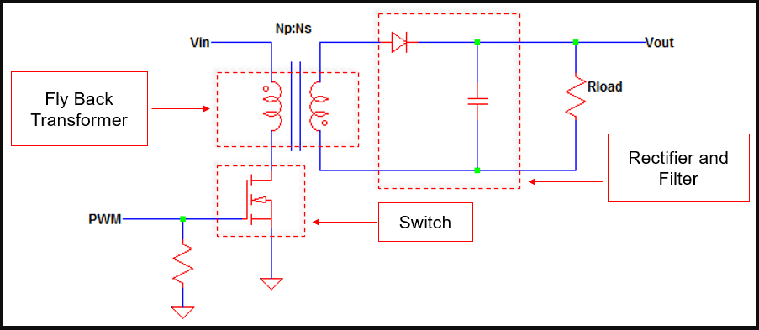

Image

Image 1 shows a simple flyback converter, it has one MOSFET (NMOS) working as a switch, the flyback transformer, which actually is a coupled inductor, one diode, and a capacitor load. There is a PWM in the circuit, which will be explained later.

So how does this work:

**1)** When the switch is ON

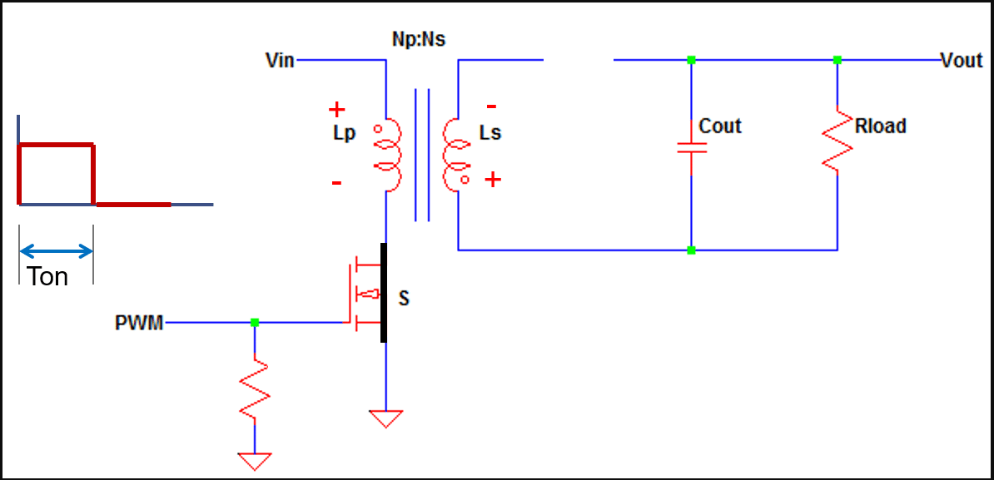

Image 2

The MOSFET, when the Vgs > Vth, will work as a closed switch, so current will flow through the Primary Inductor which will conduct and hence the inductor will store the energy in the Magnetic field. At this time (Ton), the voltage across the secondary inductor will be Vin*(Ns/Np), and the diode will be reversed biased, hence the current flowing through it will be zero; so during this time, the output voltage will be provided by the discharging of the capacitor Cout. The reverse Voltage across the diode will be Vout+ Vin*(Ns/Np).

**2)** When the Switch is OFF

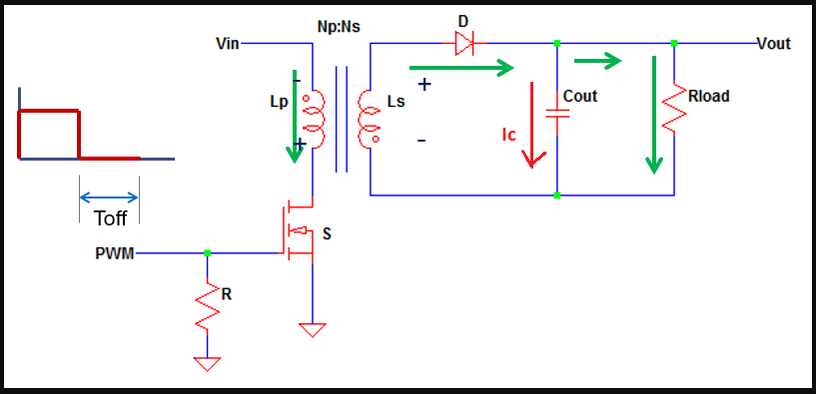

Image 3

When the switch is OFF, i.e., Vgs=0, the MOSFET will work as an open circuit so no current will flow in the primary side, but the discharging will be done during this time, the diode will conduct and hence be forward biased, therefore charging the capacitor, which will provide the output voltage while it discharges.

There are two modes of conduction in any converter: Continuous Conduction Mode (CCM), and Discontinuous Conduction Mode (DCM).

**1)** Continuous Conduction Mode

In CCM, the primary inductor is not discharged fully during the Toff time, so full energy transfer does not happen. Before the inductor is fully discharged, the next duty cycle begins (next Ton), here the inductor current ripple is not very large and always the inductor current would be greater than the inductor ripple.

2) Discontinuous Conduction Mode

In DCM, full energy transfer from primary to secondary happens, i.e. the primary inductor current goes to absolute zero during Toff. Here the current ripple is greater than the inductor current.

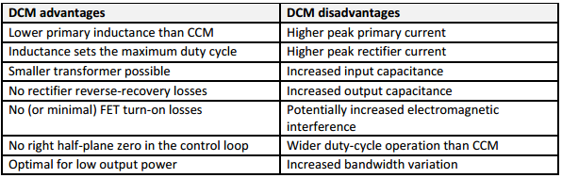

Table 3

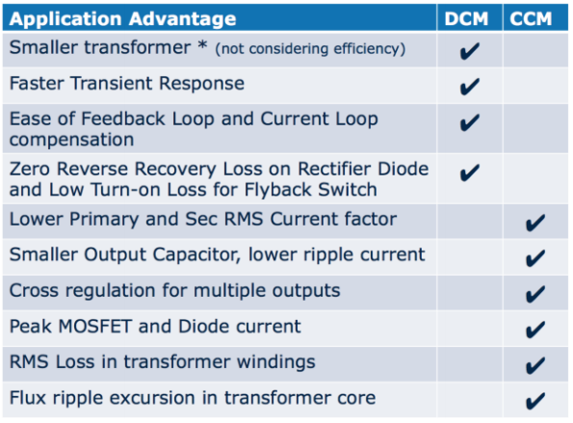

Table 4

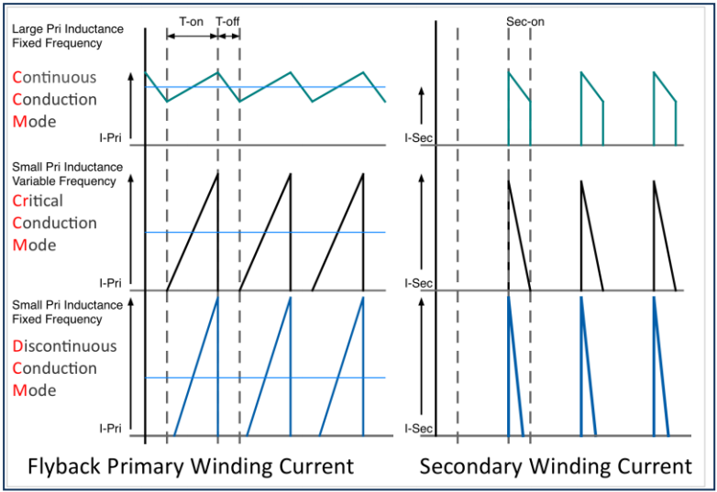

Image 4

In our case, the need for high voltage gain is required, so in order to achieve that, DCM will be used all the time, as we need the inductor to get fully discharged and the full transfer of energy is required to have a high gain. In low-power circuits, DCM is used a lot.

**Pulse Width Modulation (PWM)**

For switching purpose of the MOSFET, a pulse is required. If one applies a constant pulse, the duty cycle (Ton/Ts) will be constant throughout, but in practical scenarios, there are always protuberances (unwanted inputs), in this case, as well, some change in the input voltage or output current can vary the output voltage which is not desirable. For this reason, a PWM is required, which can be generated by a microcontroller or a PWM controller IC.

A negative feedback loop is used to compare the output voltage with a reference voltage to reduce errors and control the duty cycle accordingly, with varying the PWM ON time.

There are 2 types of PWM: Voltage Controlled PWM, and Current Controlled PWM.

In voltage-controlled PWM, there is One voltage loop coming from the output which is compared with a reference voltage in an error amplifier. The error amplifier output is then compared with another reference, which comes from a saw tooth generator (current sensing). This second error amplifier output is the PWM output which goes into the gate terminal of the MOSFET.

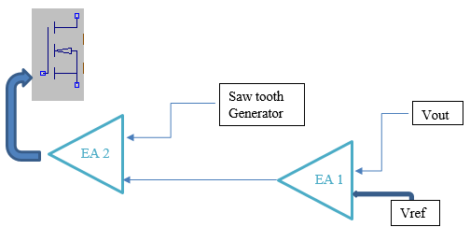

Image 5

On the other hand, in Current Controlled PWM, there are two feedback loops, one outer loop that comes from the output voltage and is compared to the Vref, and one inner current sensing loop which comes from the source of the Mosfet and is compared with the output of the first error amplifier.

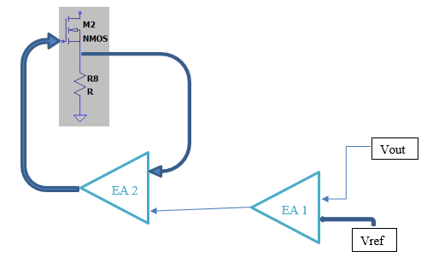

Image 6

In this project, Current Controlled PWM will be preferred because of the following advantages:

1) When there is a change in input voltage, the output voltage will be reflected in the next cycle when used in voltage control loop. However, in Current controlled PWM, this will not be a problem.

2) Right Half Plane Zero.

**PWM Control IC (UC1846)**

The IC used is UC1846, which is a current mode PWM controller IC. It is a 16 pin IC, including a shutdown pin, two pins for Error Amplifier (inverting and non-inverting) connected with a potentiometer, two pins for Current Sensing, and two pins for timing capacitor and timing resistor respectively.

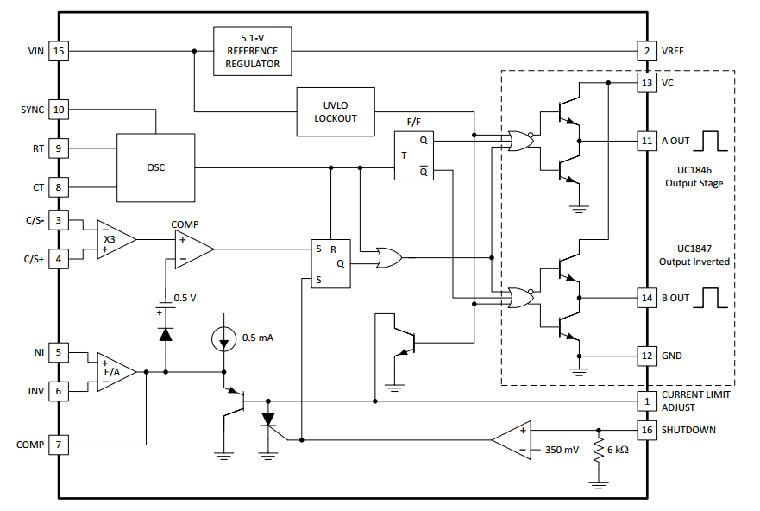

Image 7

# 

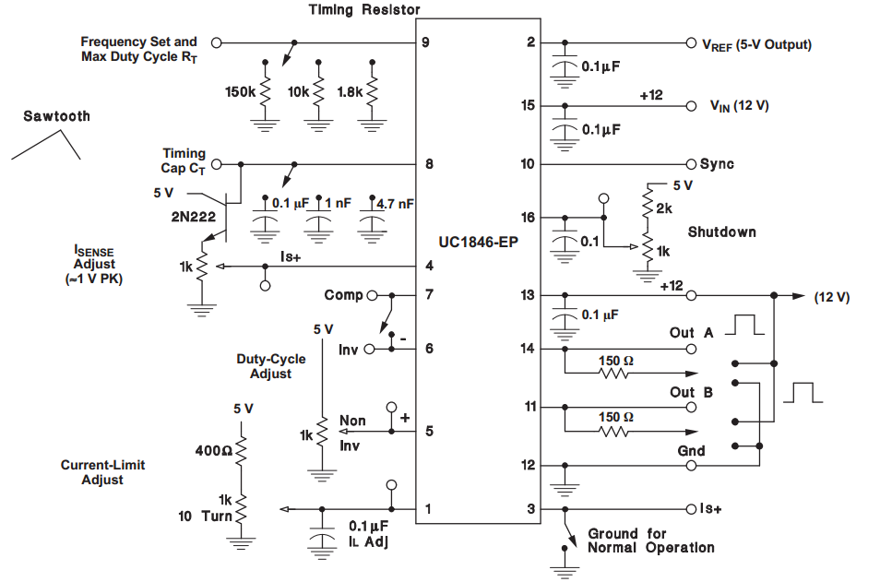

Image 8

Image 7 is the internal circuit of the IC, and Image 8 is the IC testing circuit in Open loop, where the controlling element is the potentiometer, which is connected to the Error amplifier (pin 5 and 6). There are two outputs from the IC, i.e. Out A and Out B that provides 50% duty cycle each.

# Scope/ Application

* For optical communication, satellites generally use dual-axis mirrors for giving signals the required direction.
* Those mirrors require to move in two axes (tip or tilt axis), and for the same, they require a variable voltage.
* For this application, piezo devices can be used and this project is aimed at providing a variable voltage from 0Vdc-150Vdc from an input bus of 12Vdc.

What are Piezo Devices: Devices that can convert electrical energy into mechanical energy (Displacement, Angle, etc.) are piezo devices.

Before Piezo devices were introduced, the displacement of mirrors was done with the use of motors.

Because the motors were very heavy to carry, piezo devices were the way to go in these situations.

# Block Diagram of the System

# 

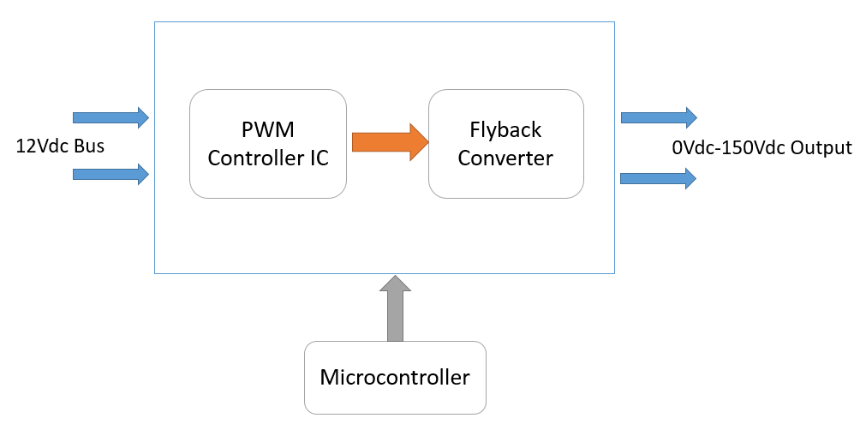

Image 9

# Flow Chart of the system

Study and Literature Review

Comparative study and Calculations

Simulations

Requirements met

?

NO

YES

Hardware Testing of Designed Converter

Schematic Design and PCB Design

Optimization of PCB Layout and Fabrication

Image 10

# Work Done

**1)** Testing of the PWM Control IC in Open Loop:

Here are some pictures of the PWM controller IC in Open loop test conditions:

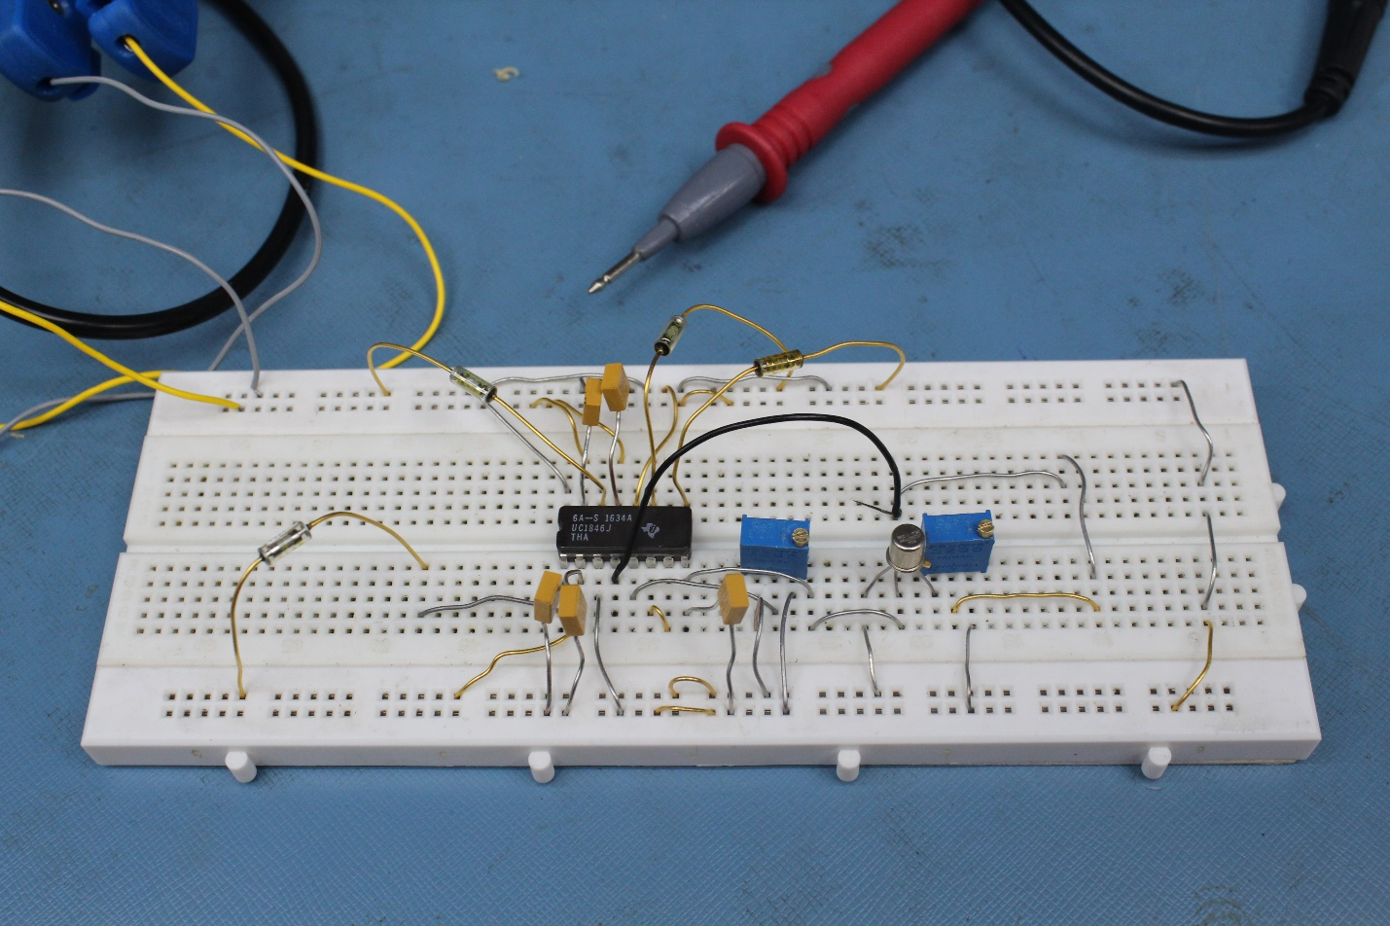

Image 11

The connections are made using the open loop test circuit shown in image 8.

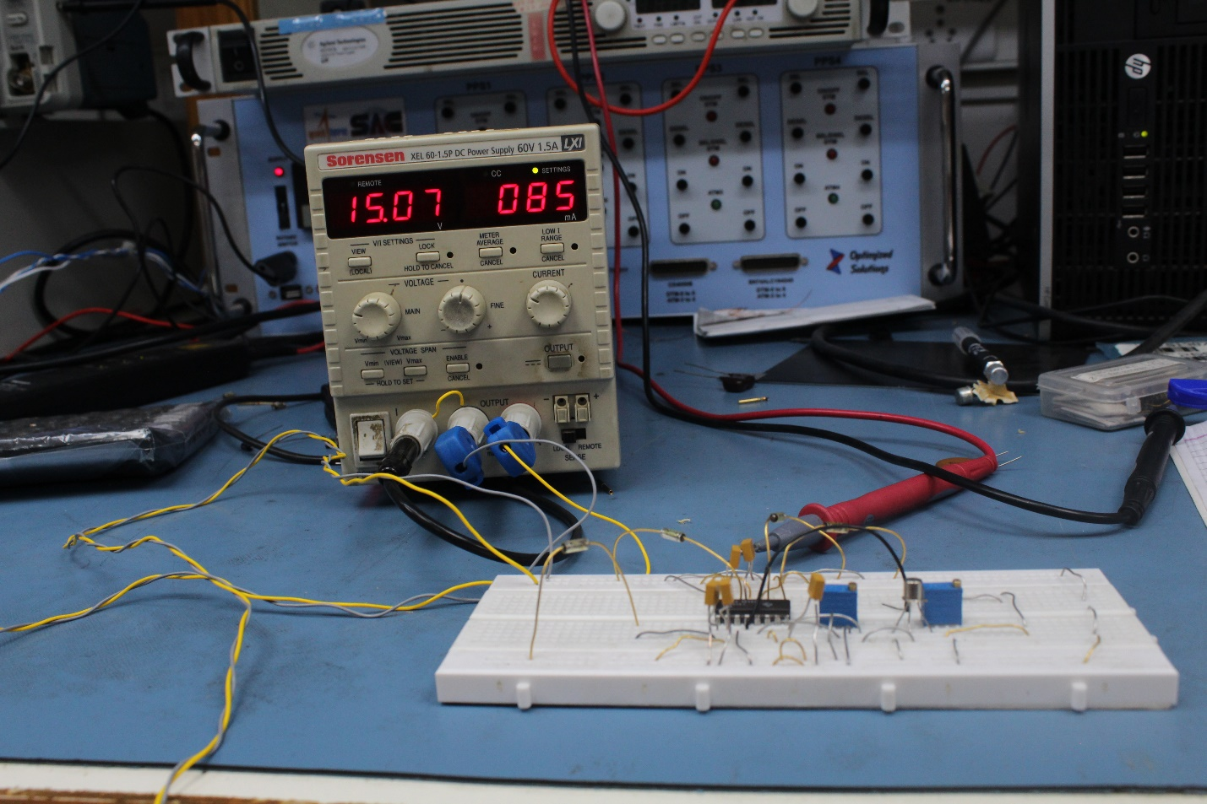

Image 12

The power supply of 15 Vdc is provided to the test circuit

**Results:**

In open loop, the error amplifier value determines the duty cycle, so by varying the potentiometer connected to pin 5 changes the duty cycle as shown below:

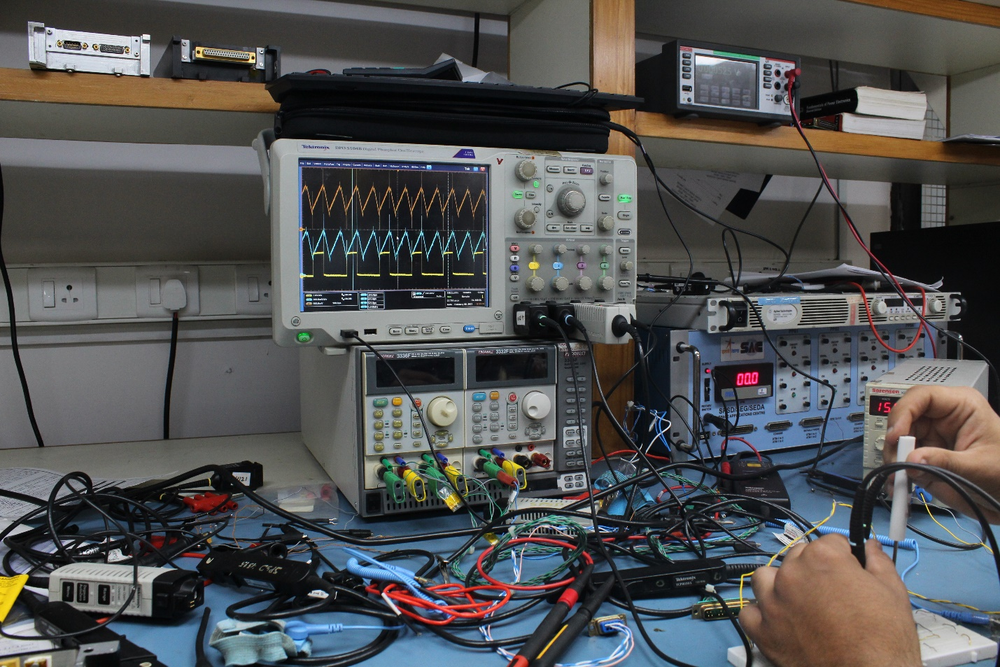

Image 13

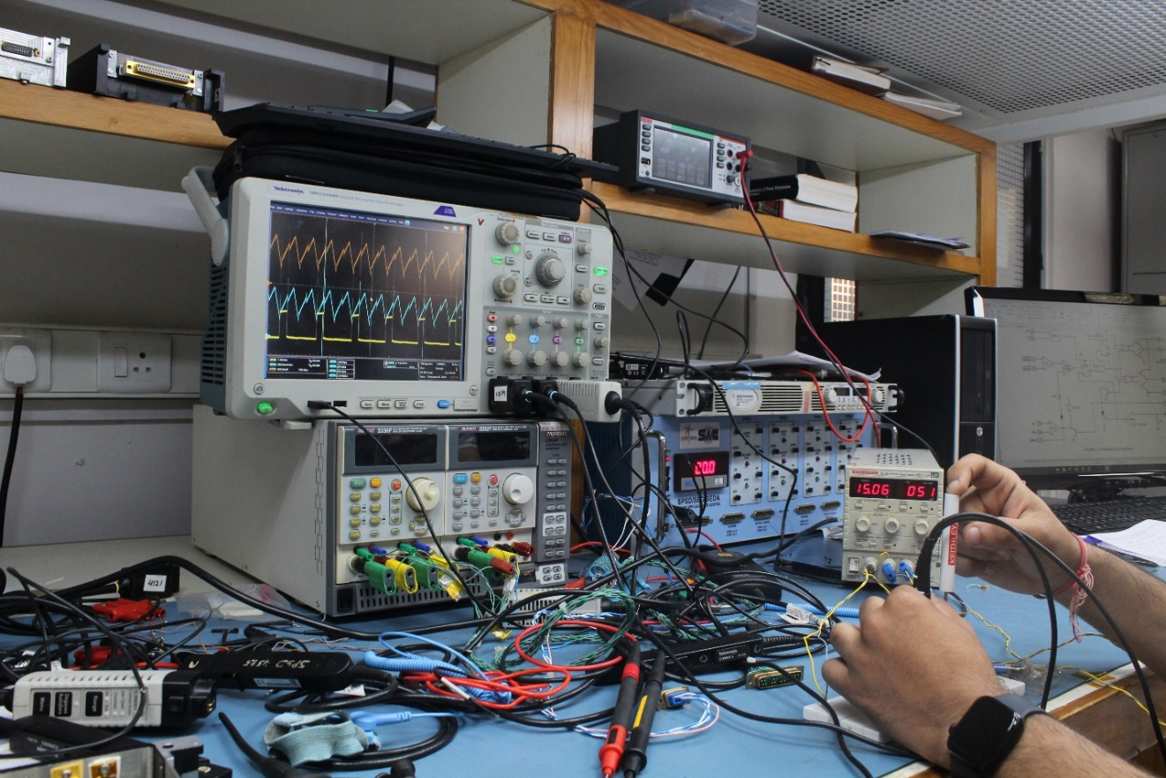

Image 14

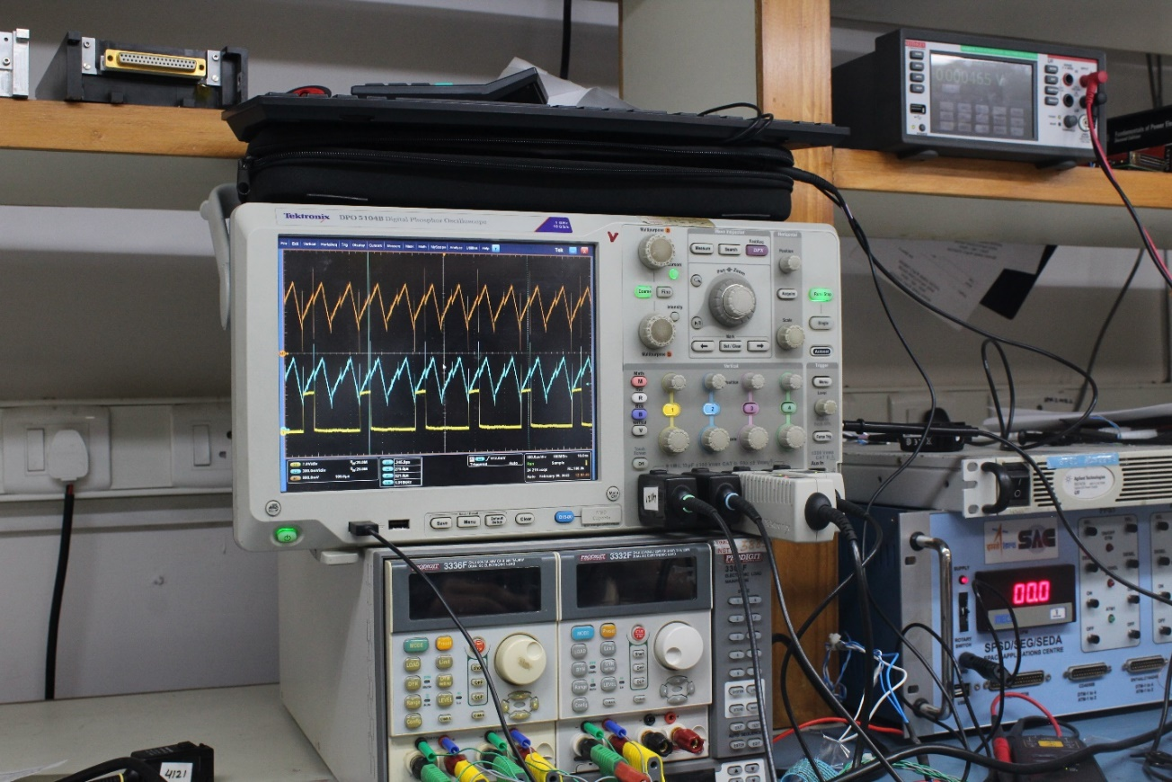

Image 15

**2)** LTSpice Simulation of Flyback converter with PWM Controller IC:

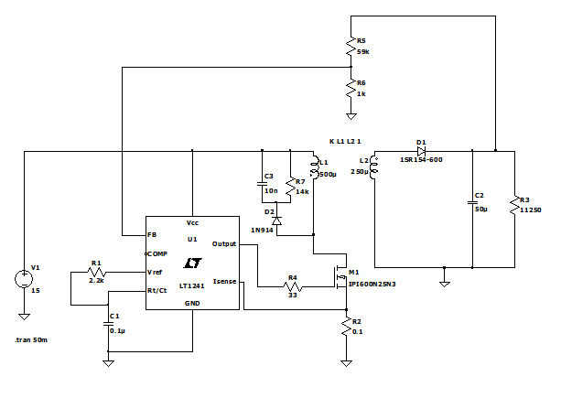

Image 16

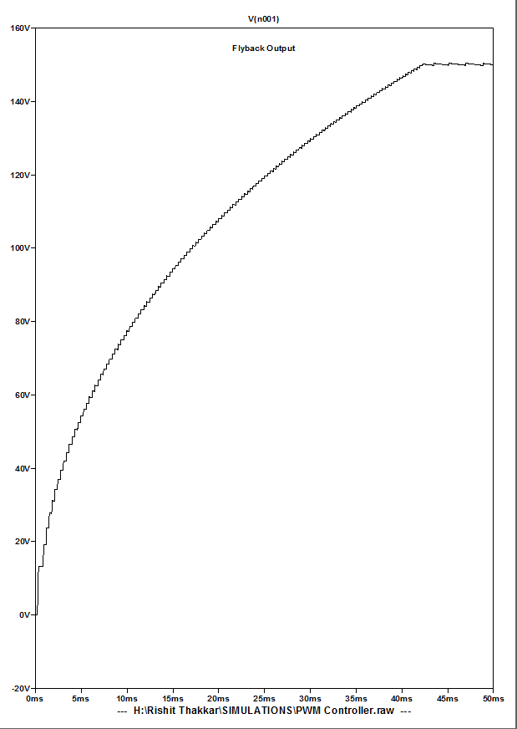

Image 17

**3)** CADSTAR Schematic Design and PCB Design (Ongoing):

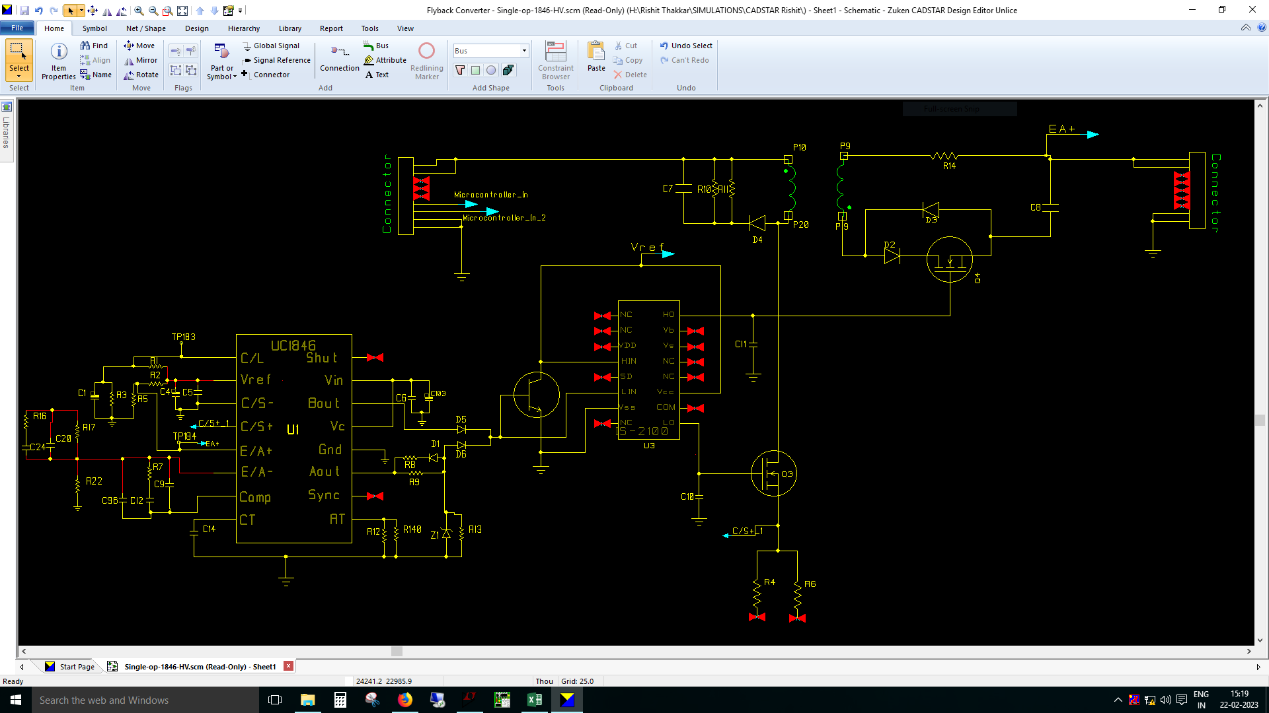

Image 18

Currently working on the end-to-end schematic of the Converter with PWM IC, All the selected components, the gate driver IC, and with the power supply from DB 9 Connecters.

Also have 2 slots in the connector for Microcontroller Input, for Variable Output, if PWM is taken from Microcontroller.

**Work Completed:**

* Literature Review
* Study and Calculations
* Simulations and Comparative study
* Component Selection
* Schematic and PCB Design (Under Progress)

# References

1. Book: - The art of electronics by Paul Horowitz
2. Book: - Fundamentals of Power Electronics by Robert Erickson
3. Book: - Switching Power Supply Design by Abraham I. Pressman
4. Book: - Mohan, Undeland, Riobbins, Power Electronics- Converters, Applications, and design, Wiley.
5. Book: - Pulse Width Modulated dc-dc Power Converters by Marian Kazimierczuk.
6. Book: - Designing control loops for linear and switching power supplies by Christophe basso
7. Dynamic System Response- Author: John M. Cimbala, Penn State University
8. Atmel | SMART ARM-based MCU datasheet(Atmel-11057-32-bit-Cortex-M3-Microcontroller-SAM3X-SAM3A_Datasheet)
9. 2N3700 NPN low power Silicon transistor - Datasheet
10. Infineon-HiRel RadHard Power-MOS - Datasheet
11. Infineon-IR2110-DataSheet (gate driver IC)
12. IS-2100ARH, IS-2100AEH Radiation Hardened High-Frequency Half Bridge Drivers - Datasheet
13. 1N6512 – 1N6519 Series - ULTRA FAST RECOVERY HIGH VOLTAGE RECTIFIER - Datasheet.
14. 1N6626US –void less hermetically sealed surface mount ultrafast recovery glass rectifiers - Datasheet.
15. SDR1DHF & SDR1DHFSMS thru SDR1NHF & SDR1NHFSMS Hyper Fast Recovery Rectifier - Datasheet.
16. Design Guide for Off-line Fixed Frequency DCM Flyback Converter - Allan A. Saliva Infineon Technologies North America (IFNA) Corp.
17. Power Tips #98: Designing a DCM flyback converter John Betten, Texas Instruments Incorporated
18. Power MOSFET Selecting MOSFETs and Consideration for Circuit Design Application Note- Toshiba.
19. Application Note AN-4147 Design Guidelines for RCD Snubber of Flyback Converters- Fairchild semiconductors.
20. Flyback Converter- snubber design- dr. ray ridley, designer series XII, switching power magazine.
21. Application Report SLUA618A–March 2017–Revised October 2018 Fundamentals of MOSFET and IGBT Gate Driver Circuits-Laszlo Balogh, Texas Instruments Incorporated
22. AN_2203_PL18_2204_004502 Gate drive for power MOSFETs in switching applications, A guide to device characteristics and gate drive techniques Authors: Peter B. Green, Liz Zheng
23. Vishal Das, Dipten Maiti, Nikhil Mondal, Sujit K. Biswas- Studies on Boost Topologies for High Boost Ratio, 2014 International Conference on Control, Instrumentation, Energy & Communication(CIEC)
24. Gheorghe Turcan, Flyback SMPS Using a Microcontroller as Control Unit, Microchip Technology Inc
25. Frank De Stasi, Working with Boost Converters, Application Report SNVA731–June 2015, Texas Instruments Incorporated
26. N.C. Pisenti,1, a) A. Restelli,1 B.J. Reschovsky,1 D.S. Barker,1 and G.K. Campbell1, An ultra-low noise, high-voltage piezo driver, arXiv:1609.03607v2 [physics.ins-det] 11 Dec 2016
27. Jim Williams, High Voltage, Low Noise, DC/DC Converters, Application Note 118, Linear Technology Corporation
28. DRV2700 Industrial Piezo Driver With Integrated Boost Converter, SLOS861C – MARCH 2015 – REVISED JANUARY 2023, Texas Instruments Incorporated
29. DRV8662 Piezo Haptic Driver with Integrated Boost Converter, SLOS709C – JUNE 2011 – REVISED DECEMBER 2022, Texas Instruments Incorporated
30. LT1241 Series, High-Speed Current Mode Pulse Width Modulators, ANALOG DEVICES, INC.
31. Brian Burk, Application Note DRV8662, DRV2700, DRV2665, and DRV2667 Configuration Guide, Texas Instruments Incorporated
32. DRV2700EVM High Voltage Piezo Driver Evaluation Kit, User's Guide SLOU403C–March 2015–Revised June 2018, Texas Instruments Incorporated
33. DRV2700EVM-HV500 High Voltage Piezo Driver Evaluation Kit, User's Guide SLOU407A–April 2015–Revised May 2015, Texas Instruments Incorporated
34. UCx846/7 Current Mode PWM Controller, SLUS352C –JANUARY 1997–REVISED DECEMBER 2015, Texas Instruments Incorporated.
35. A NEW INTEGRATED CIRCUIT FOR CURRENT MODE CONTROL, Application note- U93, Texas Instruments Incorporated.
36. C1846-EP CURRENT-MODE PWM CONTROLLER SGLS329–MAY 200, Texas Instruments Incorporated.
37. Chester Simpson, LM317, LM340, LP2975-A User's Guide to Compensating Low-Dropout Regulators, Literature Number: SNOA826, Texas Instruments Incorporated.
38. AN-20 An Applications Guide for Op Amps, Application Report SNOA621C–February 1969–Revised May 2013, Texas Instruments Incorporated.